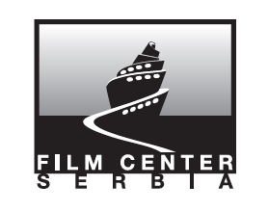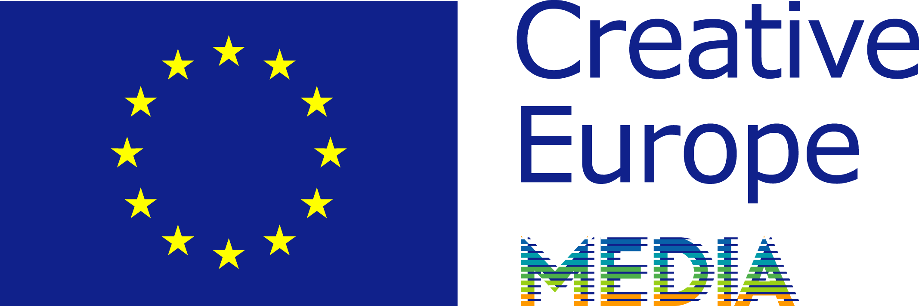

**EURODOC 2017**

**Extended deadline for the whole EURODOC programme**

**EXTENDED DEADLINE January, 20th 2017**

**Workshop for documentary producers & filmmakers**

EURODOC is a training programme specifically designed for co-producing creative documentaries at the international level, a documentary think-tank covering a wide variety of narrative styles and production modes with the aim of defending the documentary genre.

The programme consists in 3 sessions spread out over 8 months:

**SESSION 1** – Development / March 5th to 11th, 2017 (Serbia)

**SESSION 2** – Coproduction, Budgeting, Financing / June 2017

**SESSION 3** – Meeting the Commissioning Editors / October 2017 (Portugal)

A total of 30 participants are selected to take part to the programme, 5 of them coming from non-European countries. As the first session of Eurodoc 2017 programme will take place in Serbia, a selected Serbian participant will be granted a scholarship to cover his/her pedagological costs!Eurodoc offers you a special deadline.

DO [Submit your application online before](http://www.eurodoc-net.com/en/prg/participants.php) **[EXTENDED DEADLINE January, 20th 2017 !](http://www.eurodoc-net.com/en/prg/participants.php)**

!

Find the programme in detail on [EURODOC website](http://www.eurodoc-net.com/en/prg/objectifs.php).

**EURODOC 2017- First Session in Serbia**

**Workshop for documentary producers & filmmakers in Serbia**

**From March 06to March 11, 2017**

Around 30European and international documentary producers will gather, in **Serbia** for the first session of the **EURODOC 2017** programme, thanks to the support of the **Film Center Serbia**.



During these session, there will also be **a regional workshop**, offering to **a group of 12 professionals** full access to this EURODOC seminar. We will select up to 12 projects, by local producers and/or filmmakers. They will have the opportunity to work on the development of their projects with **a tutor specifically in charge of the group** and have full access to this session alongside the other EURODOC 2017 participants. The workshop focuses on **analysing the projects of the participants**, evaluating scripts, studying overall consistency and market positioning. It will be a unique opportunity to establish relationship with a group of European documentary professionals.

During the week, 2 public screenings will be organised for a broader audience, with a debate on the production process of the film and its distribution outcome.The professionals from the city will be welcomed to join these showcases and lectures and meet all EURODOC participants and experts.

**Registration**:Applications must be entered by **EXTENDED DEADLINE January, 20th 2017.**

The regional candidates will have to return the application form (signed), and all other documents must be submitted by email to the following address: [eurodoc@wanadoo.fr](mailto:eurodoc@wanadoo.fr)

**Your application file for the Regional group** (in English) will include:

- Synopsis & Treatment (3 to 5 pages)

- Budget & financing plan

- CV of the filmmaker, CV of the applicant & company profile *

- Completed and signed application form *

- Vimeo link of a previous film by the director

* Applicants from institutions (without a project) should submit only items marked with a *

**Regional group Participants Profiles**:

- Producers

- Managing directors from production companies

- Production managers

- Filmmakers

- Executives from institutions in charge of documentary funds

**Costs for the regional applicants**:

The pedagogical cost for these session in **Serbia**is covered thanks to the EURODOC 2017 programme partners as well as 70% of theaccommodation expenses for the session.The participants will have to cover only 30% of the accommodation expenses and the travel expenses in case they come from Province.

For more information, please ask to eurodoc@wanadoo.fr

**EURODOC team**:

**HeinoDeckert**, Producer at Ma.Ja.De (Germany), English-speaking group leader

**MatthieuBelghitti**, Producer at What’s Up Films (France), French-speaking group leader.

**Head of Programme**:Jacques Bidou

**Programme Coordinator:**Melina Chosson / DelphinePellereau

**Assistant Coordinator:**FaustineHennion



### EURODOC 2017Session in Serbia

A workshop for documentary producers

**March 06 – March 11, 2017**

### APPLICATION FORM FOR REGIONAL GROUP

**Please return before January 13, 2017**

|  |  |
| --- | --- |
| **Full Name:** |  |
| **Company name:** | |
| **Company address:** | |
| **Zip Code:** | **City:** |
| **Country:** | **Telephone:** |
| **Fax:** | **Mobile:** |
| **Mail:** | **Web address:** |
| **Nationality:** | **Position:** |

***I apply for the EURODOC workshop as:***

**With the project** (title) :

**Full name of the director**:

**Please send by e-mail:**

|  |
| --- |
| **Synopsis : 1 page** |
| **Treatment: 5 pages maximum** |
| **Production strategy** |
| **Budget and financing plan** |
| **CV of the director**  **CV of the producer**  **Company profile** |
| **1 DVD of previous film by the filmmaker** (or vimeo link) |
| **Signed application form\*** (by e-mail) |

I have understood and accepted the following:

- the working language will be English.

- the pedagogical fee for my participation is covered thanks to a scholarship granted through EURODOC &the session partners.

- I will cover the travel expenses as well as 30% of the accommodation costs for the workshop.

Date : Signature :

*The EURODOC programme issupported by the Creative Europe programme of the EuropeanCommunity,*

*the Centre National de la Cinématographie and Procirep (France) and the partnerswelcoming the sessions.*